#TRAFFIC LIGHT

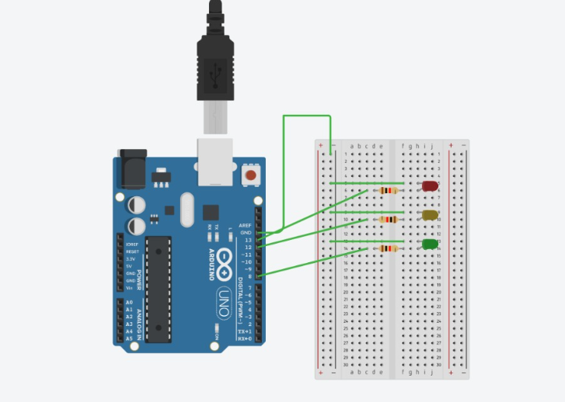
int led1=13;
int led2=12;
int led3=8;

void setup()
{
pinMode(led1,OUTPUT);
pinMode(led2,OUTPUT);
pinMode(led3,OUTPUT);

}

void loop()
{
digitalWrite(led1, HIGH);
delay(1000); // Wait for 1000 millisecond(s)
digitalWrite(led1, LOW);
delay(1000); // Wait for 1000 millisecond(s)

digitalWrite(led2, HIGH);
delay(1000); // Wait for 1000 millisecond(s)
digitalWrite(led2, LOW);
delay(1000); // Wait for 1000 millisecond(s)

digitalWrite(led3, HIGH);
delay(1000); // Wait for 1000 millisecond(s)
digitalWrite(led3, LOW);
delay(1000); // Wait for 1000 millisecond(s)
}

